Training Guide for Sales and Customer Support

## Background:

Low levels of physical activity are associated with an estimated $117B in annual health care costs. Most of these costs are entirely preventable through moderate amounts of physical exercise and a balanced diet. An estimated 3 in 4 Americans do not get enough physical activity. Diseases such as heart disease and Type 2 Diabetes are easily preventable simply through regular moderate physical activity. As a health care provider, we should always be striving to reduce our costs in a way that doesn’t affect the quality of care we provide to our patients. Our direct costs can be reduced through encouraging our existing subscribers and patients to be heathier through exercise and diet. Through the use of a fitness application, we can directly encourage and incentivize users to care for their health reducing our eventual costs.

## Market background:

The ideal market and audience are those who are most at risk for heart disease or Type 2 Diabetes aka patients or subscribes that have not really exercised before. The most potential cost savings will be from our existing customers. In addition to these customers, the functionality and appeal of our application can also be pitched to those who are not our current patients or subscribers. The application can be used to attract more subscribers to our health care plans, which can be anyone who has coverage but with a competitor.   
  
For this application, our main competitors will be other health care providers and those using MyFitnessPal. If we have patients who are using MyFitnessPal, they should be the easiest and priority to transition to our application. Otherwise, those who are not under our care, we want to use our application as a talking point to bring them from other care providers to our plans.

## Product Background:

The product we will be releasing is Health4U. The main product value proposition is that by being directly connected to their health care providers, subscribers and patients will be more likely to use the application. Our three main features are:

* Pre-set Goals page to allow users to easily follow a plan
* Easy tracking and personal health data all on one page
* Easy to use and access rewards page to further incentivize users to keep on track with their goals

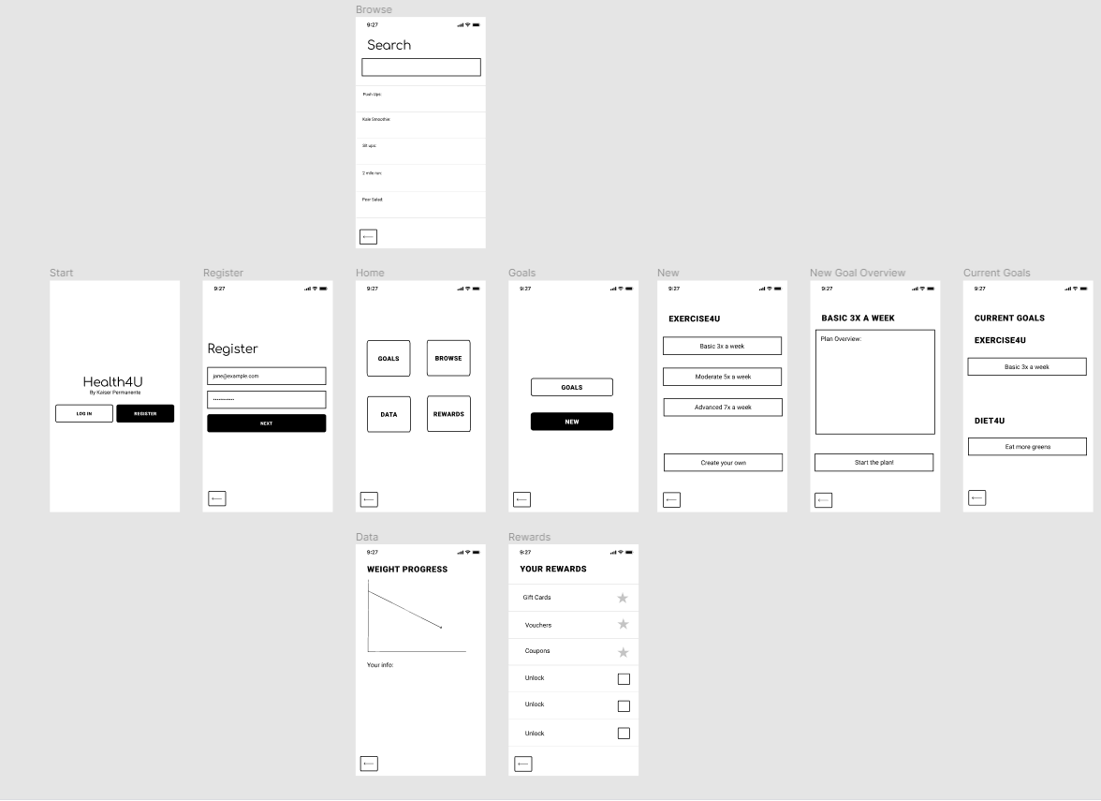

**Sales and customer support need to be aware that although users are downloading the application at a good growth rate, only 10% of users are allowing the application to send push notifications. When pitching the product to users, we need to make sure that we pitch to them the importance and how push notifications can remind users to interact to stay on track with health goals. Customer support should mention this as an additional feature of the application as well.**

## Pricing:

Pricing is free to download for all of existing care patients as are all current features. Rewards for achieving goals can be anywhere from $10-$50 depending on the level of goals that are reached. In the feature, we may add premium features that require further payment or subscriptions.